

International School

**Capstone Project 2**

CMU-SE 451

**Database Design Document**

**Version 2.1**

**Date:** 14/04/2023

**Craft Village Pollution Monitor System**

**Submitted by**

**Ca, Van Cong Le**

**Huy, Bui Duc**

**Phuc, Hua Hoang**

**Trung, Nguyen Thanh**

**Nhan, Huynh Ba**

**Approved by**

**Ph.D. Nguyen Thanh Binh**

**Proposal Review Panel Representative:**

Name Signature Date

**Capstone Project 2 - Mentor:**

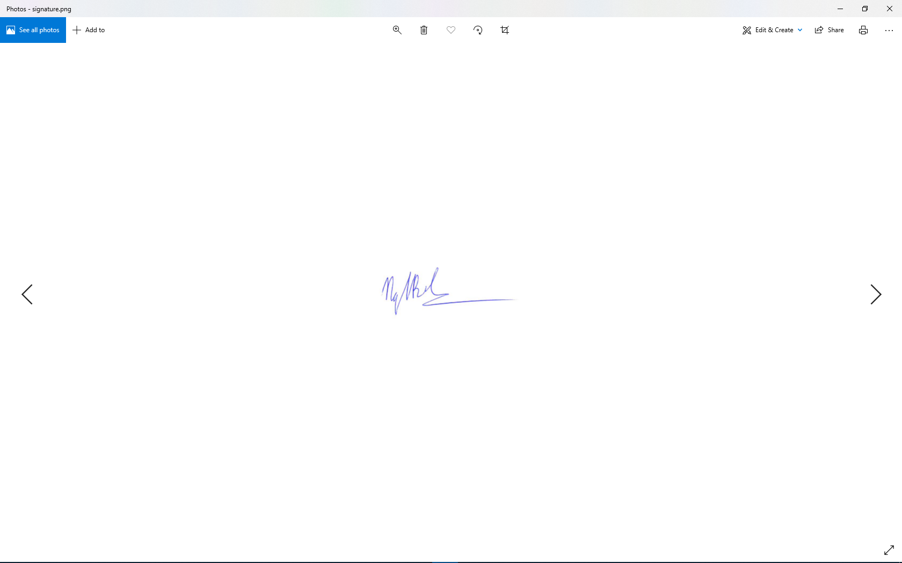

Name Signature Date

**PROJECT INFORMATION**

|  |  |  |  |
| --- | --- | --- | --- |
| **Project acronym** | CVPMS | | |
| **Project Title** | Craft Village Pollution Monitor System | | |
| **Start Date** | 01/03/2023 | **End Date** | 15/05/2023 |
| **Lead Institution** | International School, Duy Tan University | | |
| **Project Mentor** | Ph.D. Thanh Binh, Nguyen | | |
| **Scrum master / Project Leader & contact details** | Ca, Van Cong Le  *Email:* cascabusiness@gmail.com  *Tel:* 0352707895 | | |
| **Partner Organization** |  | | |
| **Project Web URL** | [*https://github.com/Casca113s2/craft-village-pollution-monitor-system*](https://github.com/Casca113s2/craft-village-pollution-monitor-system) | | |
| **Team members** | **Name** | **Email** | **Tel** |
| 25211207666 | Ca, Van Cong Le | [cascabusiness@gmail.com](http://cascabusiness@gmail.com) | 0352707895 |
| 25211215894 | Huy, Bui Duc | [duchuyltt122@gmail.com](http://duchuyltt122@gmail.com) | 0818648090 |
| 25211203702 | Nhan, Huynh Ba | [nhanhuynh1409@gmail.com](mailto:nhanhuynh1409@gmail.com) | 0935430785 |
| 25211204084 | Phuc, Hua Hoang | [phuchuho0402@gmail.com](http://phuchuho0402@gmail.com) | 0905639682 |
| 25211215133 | Trung, Nguyen Thanh | [nguyenttrung2601@gmail.com](http://nguyenttrung2601@gmail.com) | 0774496838 |

DOCUMENT NAME

|  |  |  |  |
| --- | --- | --- | --- |
| **Document Title** | Database Design Document | | |
| **Author(s)** | Phuc, Hua Hoang | | |
| **Date** | 14/04/2023 | **File Name** | C2SE.01_CVPMS_Database-Design-Document_v2.1.docx |

REVISION HISTORY

| **Version** | **Date** | **Comments** | **Author** | **Approval** |
| --- | --- | --- | --- | --- |
| 1.0 | 18/09/2022 | Create location entities | Hua Hoang Phuc |  |
| 1.1 | 02/10/2022 | Create user system | Hua Hoang Phuc |  |
| 1.2 | 20/10/2022 | Create survey system | Hua Hoang Phuc |  |
| 2.0 | 01/03/2023 | Create question and answer entities | Phuc, Hua Hoang |  |
| 2.1 | 14/04/2023 | Create data set entity | Phuc, Hua Hoang |  |

**Approve Document:** Sign in to approve the document

|  |  |  |  |
| --- | --- | --- | --- |
| **Mentor** | Binh, Nguyen Thanh | Date | 13/05/2023 |
| Sign |  |
| **Scrum Master** | Ca, Van Cong Le | Date | 13/05/2023 |
| Sign |  |
| **Scrum Member** | Huy, Bui Duc | Date | 13/05/2023 |
| Sign |  |
| **Scrum Member** | Nhan, Huynh Ba | Date | 13/05/2023 |
| Sign |  |
| **Scrum Member** | Phuc, Hua Hoang | Date | 13/05/2023 |
| Sign |  |
| **Scrum Member** | Trung, Nguyen Thanh | Date | 13/05/2023 |
| Sign |  |

Table Of Contents

1. Introduction 7

1.1. Purpose 7

1.2. Goal 7

1.3. Scope 7

1.4. Definitions, Acronyms and Abbreviations 8

2. Database Design For Sprint 1 8

2.1. Table Overview 8

2.2. Entity Relationship Diagram 9

2.3. Table Relationship Diagram 10

2.4. Detail 11

2.4.1. AD_COUNTRY 11

2.4.2. AD_PROVINCE 11

2.4.3. AD_DISTRICT 11

2.4.4. AD_WARD 11

2.4.5. VILLAGE 12

2.4.6. UR_USER 12

2.4.7. UR_ROLE 12

2.4.8. USER_ROLE 13

2.4.9. UR_SESSION 13

2.4.10. USER_SURVEY 13

2.4.11. SR_SURVEY_QUESTION 13

2.4.12. SR_SURVEY_QUESTION_ANSWER 14

2.4.13. HOUSEHOLD_SURVEY 14

3. Database Design For Sprint 4 14

3.1. Table Overview 14

3.2. Entity Relationship Diagram 15

3.3. Table Relationship Diagram 16

3.4. Detail 17

3.4.1. DATA_SET 17

**Table Of Figures**

**Figure 1.** Entity Relationship Diagram Sprint 1 9

**Figure 2.** Table Relationship Diagram Sprint 1 10

**Figure 3.** Entity Relationship Diagram Sprint 4 15

**Figure 4.** Table Relationship Diagram Sprint 4 16

**Table Of Tables**

**Table 1.** Definitions, Acronyms and Abbreviations 8

**Table 2.** Table Overview Sprint 1 8

**Table 3.** AD_COUNTRY 11

**Table 4.** AD_PROVINCE 11

**Table 5.** AD_DISTRICT 11

**Table 6.** AD_WARD 11

**Table 7.** VILLAGE 12

**Table 8.** UR_USER 12

**Table 9.** UR_ROLE 12

**Table 10.** USER_ROLE 13

**Table 11.** UR_SESSION 13

**Table 12.** USER_SURVEY 13

**Table 13.** SR_SURVEY_QUESTION 13

**Table 14.** SR_SURVEY_QUESTION 14

**Table 15.** HOUSEHOLD_SURVEY 14

**Table 16.** Table Overview Sprint 4 14

**Table 17.** DATA_SET 17

# Introduction

## Purpose

Place information system’s database design document describes structure of database and file structure of system. Database Design document will introduce all attribute the System that will help developer and tester base on this design to implement and test.

## Goal

To create database tables most accurate.

## Scope

* This Database Design Document provides the basic for “Craft Village Pollution Monitor System” Database design.
* It defines the database that will support the “Craft Village Pollution Monitor System” Data Model.
* It describes both logical and physical definition, non-functional issues, and the database interfaces; storage aspects are defined in the physical database design sections.
* The following topics are covered in this document:
* Assumptions and decisions on database design.
* Entity-mapping.
* Table column definitions.
* Primary, unique and foreign key definitions.
* Column and row level validation rules (check constraints).
* Rule for populating specific columns (sequences, derivations, demoralized (column)).
* Interfaces and dependencies with other components.
* Data access description.
* The database design for “Craft Village Pollution Monitor System” is composed of definitions for database objects derived by mapping entities to tables attributes to columns, unique identifiers to unique keys and relationship to foreign keys.
* During design, these initial definitions are enhanced to support the functionality described in the functional specification/ user stories and defined in the primary and supporting modules of the application high level design.

## Definitions, Acronyms and Abbreviations

**Table 1.** Definitions, Acronyms and Abbreviations

|  |  |  |
| --- | --- | --- |
| **Abbreviations** | **Description** | **Comment** |
| PK/FK | Primary/ Foreign Key | Use to indicate a file is a Primary or Foreign key in a table |
| ERD | Entity Relationship Diagram | Show the relationship between entities in the system |
| Auto | Auto increment | Auto increment |

# Database Design For Sprint 1

## Table Overview

**Table 2.** Table Overview Sprint 1

| **No** | **Table name** | **Short Description** |
| --- | --- | --- |
| 1 | AD_COUNTRY | This table contains the information about countries. |
| 2 | AD_PROVINCE | This table contains the information about provinces |
| 3 | AD_DISTRICT | This table contains the information about districts |
| 4 | UR_USER | This table shows all information of user |
| 5 | UR_ROLE | This table contains the roles |
| 6 | USER_ROLE | This table shows the roles of users |
| 7 | UR_SESSION | This table saves the sessions |
| 8 | USER_SURVEY | This table saves surveys of personal user |
| 9 | SR_SURVEY_QUESTION | This table contains the information about questions in household survey. |
| 10 | SR_SURVEY_QUESTION_ANSWER | This table contains the information about answers for each question. |
| 11 | HOUSEHOLD_SURVEY | This table contains the information about household answers. |

## Entity Relationship Diagram

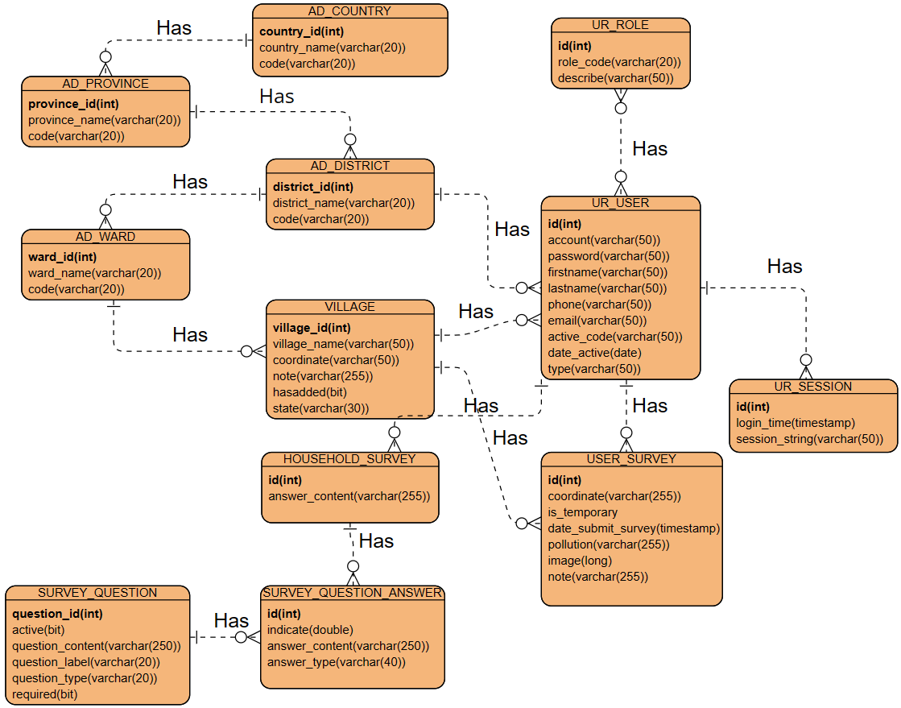

**Figure 1.** Entity Relationship Diagram Sprint 1

## Table Relationship Diagram

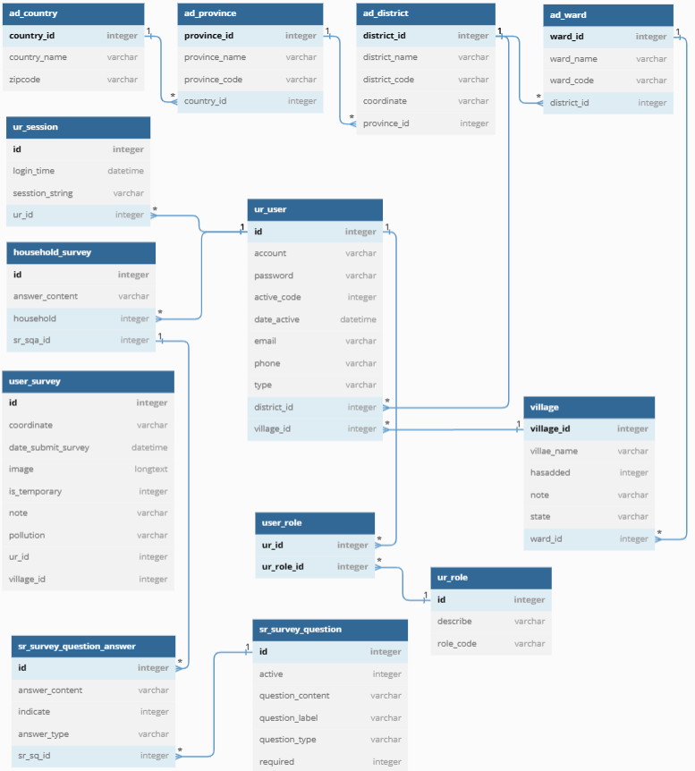

**Figure 2.** Table Relationship Diagram Sprint 1

## Detail

### AD_COUNTRY

**Table 3.** AD_COUNTRY

|  |  |  |  |  |  |
| --- | --- | --- | --- | --- | --- |
| **Attributes** | **Datatype** | **Null** | **Key** | **Default** | **Extra** |
| Country_id | int | Not | PK |  | Auto |
| Country_name | varchar(50) | Not |  |  |  |
| code | varchar(20) | Allow |  |  |  |

### AD_PROVINCE

**Table 4.** *AD_PROVINCE*

|  |  |  |  |  |  |
| --- | --- | --- | --- | --- | --- |
| **Attributes** | **Datatype** | **Null** | **Key** | **Default** | **Extra** |
| Province_id | int | Not | PK |  | Auto |
| Province_name | varchar(50) | Not |  |  |  |
| code | varchar(20) | Allow |  |  |  |
| Country_id | int | Not | FK |  |  |

### AD_DISTRICT

**Table 5.** AD_DISTRICT

|  |  |  |  |  |  |
| --- | --- | --- | --- | --- | --- |
| **Attributes** | **Datatype** | **Null** | **Key** | **Default** | **Extra** |
| District_id | int | Not | PK |  | Auto |
| District_name | varchar(50) | Not |  |  |  |
| Code | varchar(20) | Allow |  |  |  |
| Coordinate | Varchar(50) | Not |  |  |  |
| Province_id | int | Not | FK |  |  |

### AD_WARD

**Table 6.** AD_WARD

|  |  |  |  |  |  |
| --- | --- | --- | --- | --- | --- |
| **Attributes** | **Datatype** | **Null** | **Key** | **Default** | **Extra** |
| ward_id | int | Not | PK |  | Auto |
| ward_name | varchar(50) | Not |  |  |  |
| Code | varchar(20) | Allow |  |  |  |
| district_id | int | Not | FK |  |  |

### VILLAGE

**Table 7.** VILLAGE

|  |  |  |  |  |  |
| --- | --- | --- | --- | --- | --- |
| **Attributes** | **Datatype** | **Null** | **Key** | **Default** | **Extra** |
| village_id | int | Not | PK |  | Auto |
| village_name | varchar(50) | Not |  |  |  |
| Coordinate | varchar(50) | Not |  |  |  |
| Note | varchar(255) | Allow |  |  |  |
| Hasadded | int | Not |  | 0 |  |
| State | Varchar(3) | Not |  | “000” |  |
| ward_id | int | Not | FK |  |  |

### UR_USER

**Table 8.** *UR_USER*

|  |  |  |  |  |  |
| --- | --- | --- | --- | --- | --- |
| **Attributes** | **Datatype** | **Null** | **Key** | **Default** | **Extra** |
| Id | int(11) | Not | PK |  | Auto |
| Account | varchar(50) | Not |  |  |  |
| password | varchar(50) | Not |  |  |  |
| Firstname | varchar(50) | Not |  |  |  |
| Lastname | varchar(50) | Not |  |  |  |
| Phone | varchar(50) | Not |  |  |  |
| Active_code | varchar(50) | Not |  |  |  |
| Date_active | timestamp | Not |  |  |  |
| District_id | int | Allow | FK |  |  |
| Village_id | int | Allow | FK |  |  |

### UR_ROLE

**Table 9.** UR_ROLE

|  |  |  |  |  |  |
| --- | --- | --- | --- | --- | --- |
| **Attributes** | **Datatype** | **Null** | **Key** | **Default** | **Extra** |
| Id | int | Not | PK |  | Auto |
| Role_code | varchar(20) | Not |  |  |  |
| Describe | varchar(50) | Allow |  |  |  |

### USER_ROLE

**Table 10.** USER_ROLE

|  |  |  |  |  |  |
| --- | --- | --- | --- | --- | --- |
| **Attributes** | **Datatype** | **Null** | **Key** | **Default** | **Extra** |
| Ur_id | int | Not | PK, FK |  |  |
| Ur_role_id | int | Not | PK, FK |  |  |

### UR_SESSION

**Table 11.** UR_SESSION

|  |  |  |  |  |  |
| --- | --- | --- | --- | --- | --- |
| **Attributes** | **Datatype** | **Null** | **Key** | **Default** | **Extra** |
| Id | int | Not | PK |  | Auto |
| Login_time | timestamp | Not |  |  |  |
| Session_string | varchar(50) | Not |  |  |  |
| Ur_id | int | Not | FK |  |  |

### USER_SURVEY

**Table 12.** USER_SURVEY

|  |  |  |  |  |  |
| --- | --- | --- | --- | --- | --- |
| **Attributes** | **Datatype** | **Null** | **Key** | **Default** | **Extra** |
| Id | int | Not | PK |  | Auto |
| Coordinate | varchar(255) | Not |  |  |  |
| Is_temporary | varchar(20) | Not |  |  |  |
| Date_submit_survey | timestamp | Not |  |  |  |
| Pollution | varchar(255) | Not |  |  |  |
| Note | varchar(255) | Allow |  |  |  |
| Image | longtext | Not |  |  |  |
| Village_id | int | Not | FK |  |  |
| Ur_id | int | Not | FK |  |  |

### SR_SURVEY_QUESTION

**Table 13.** SR_SURVEY_QUESTION

| **Attributes** | **Datatype** | **Null** | **Key** | **Default** | **Extra** |
| --- | --- | --- | --- | --- | --- |
| Id | int | Not | PK |  | Auto |
| Question_content | varchar(255) | Not |  |  |  |
| Question_label | varchar(20) | Allow |  |  |  |
| Question_type | Varchar(20) | Not |  |  |  |
| Active | int | Not |  | 1 |  |
| Required | Int | Not |  | 0 |  |

### SR_SURVEY_QUESTION_ANSWER

**Table 14.** SR_SURVEY_QUESTION

|  |  |  |  |  |  |
| --- | --- | --- | --- | --- | --- |
| **Attributes** | **Datatype** | **Null** | **Key** | **Default** | **Extra** |
| Id | int | Not | PK |  | Auto |
| Answer_content | Varchar(255) | Not |  |  |  |
| Answer_type | varchar(50) | Not |  |  |  |
| indicate | int | Allow |  |  |  |
| Sr_sq_id | Int | Not | FK |  |  |

### HOUSEHOLD_SURVEY

**Table 15.** HOUSEHOLD_SURVEY

|  |  |  |  |  |  |
| --- | --- | --- | --- | --- | --- |
| **Attributes** | **Datatype** | **Null** | **Key** | **Default** | **Extra** |
| Id | double | Not | PK |  | Auto |
| Answer_content | Varchar(255) | Not |  |  |  |
| Household | Int | Not | FK |  |  |
| Sr_sqa_id | Int | Not | FK |  |  |

# Database Design For Sprint 4

## Table Overview

**Table 16.** Table Overview Sprint 4

|  |  |  |
| --- | --- | --- |
| **No** | **Table name** | **Short Description** |
| 1 | DATA_SET | This table contains data to detect and train pollution. |

## Entity Relationship Diagram

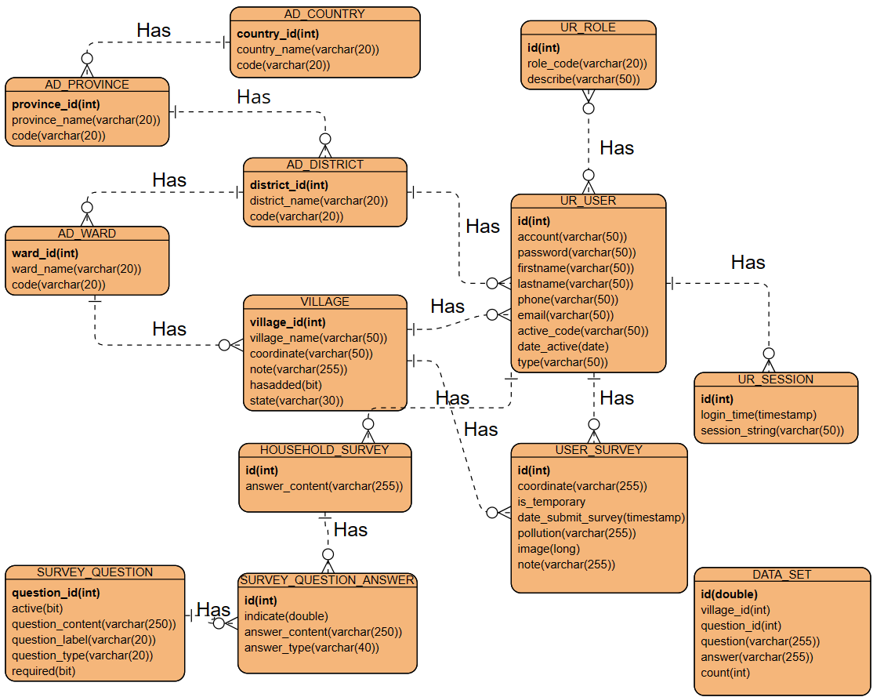

**Figure 3.** Entity Relationship Diagram Sprint 4

## Table Relationship Diagram

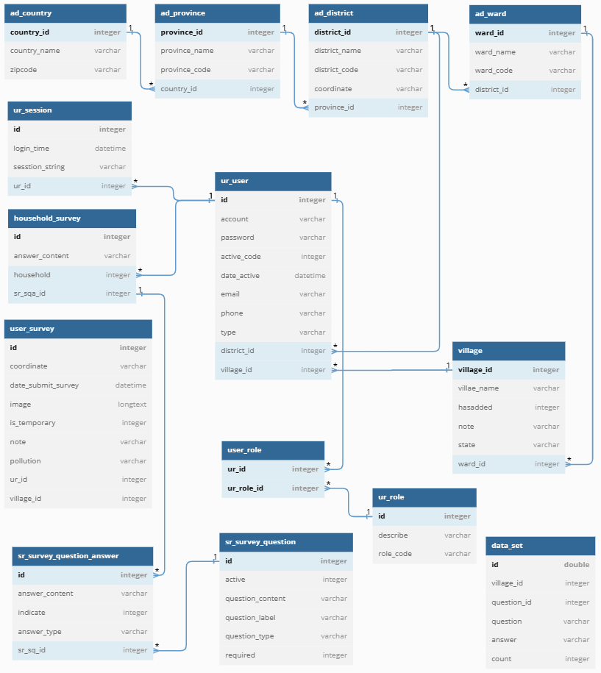

**Figure 4.** Table Relationship Diagram Sprint 4

## Detail

### DATA_SET

**Table 17.** DATA_SET

|  |  |  |  |  |  |
| --- | --- | --- | --- | --- | --- |
| **Attributes** | **Datatype** | **Null** | **Key** | **Default** | **Extra** |
| Id | Double | Not | PK |  |  |
| Village_id | int | Not |  |  |  |
| Question_id | Int | Not |  |  |  |
| Question | Varchar(255) | Not |  |  |  |
| Answer | Varchar(255) | Not |  |  |  |
| Count | Int | Not |  |  |  |